Brandon Lee  
14010627X  
11/27/14  
Lab 10

*Complete project is included. Full working source code can be found there.*

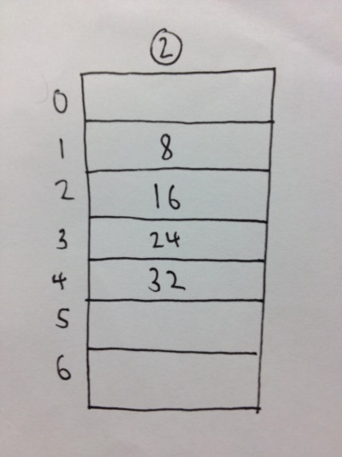**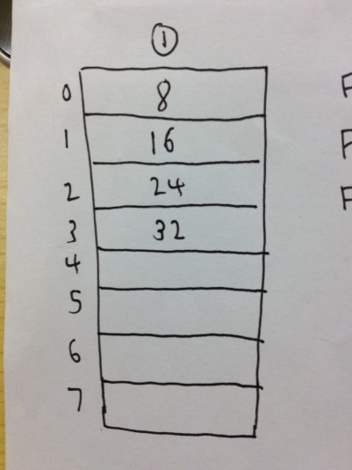Problem 1 – Sequence 8,16,24,32**

1. Linear Probing; Array Size: 8
   1. Find 8 – 1 (array cell 0)
   2. Find 16 – 2 (array cell 1)
   3. Find 24 – 3 (array cell 2)
   4. Find 32 – 4 (array cell 3)
2. Linear Probing; Array Size: 7
   1. Find 8 – 1 (array cell 1)
   2. Find 16 – 1 (array cell 2)
   3. Find 24 – 1 (array cell 3)
   4. Find 32 – 1 (array cell 4)
3. 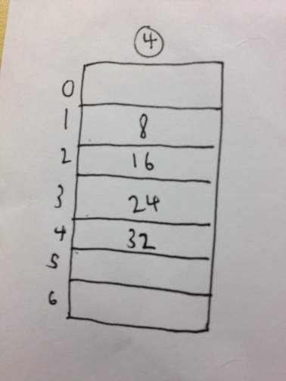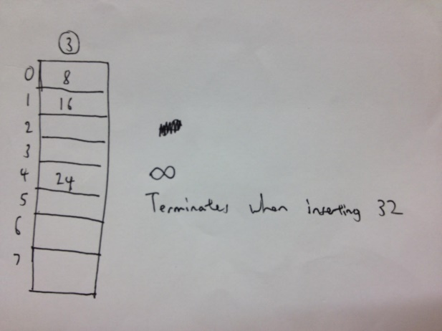Quadratic Probing; Array Size: 8
   1. Find 8 – 1 (array cell 0)
   2. Find 16 – 2 (1 attempt needed, array cell 1)
   3. Find 24 – 3 (2 attempts needed, array cell 4)
   4. Find 32 – Infinite loop in insertion, terminated
4. Quadratic Probing; Array Size: 7
   1. Find 8 – 1 (array cell 1)
   2. Find 16 – 1 (array cell 2)
   3. Find 24 – 1 (array cell 3)
   4. 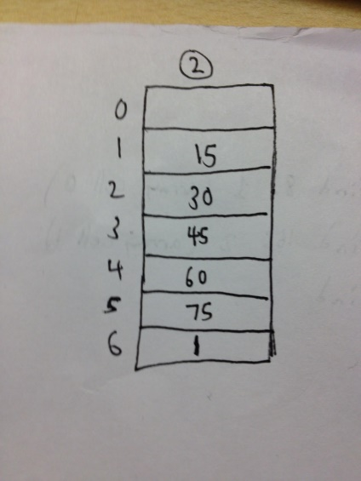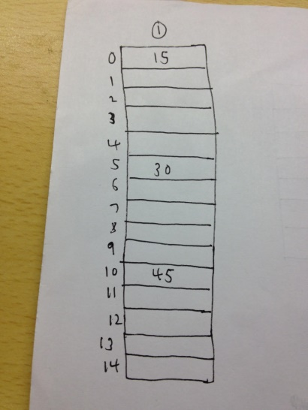Find 32 – 1 (array cell 4)

**Problem 2 – Sequence 15, 30, 45, 60, 75, 1**

1. Double Hashing; Array Size: 15
   1. Find 15 – 1 (array cell 0)
   2. Find 30 – 2 (1 attempt needed, array cell 5)
   3. Find 45 – 3 (2 attempts needed, array cell 10)
   4. Find 60 – Infinite loop in insertion, terminated
2. Double Hashing; Array Size: 7
   1. Find 15 – 1 (array cell 1)
   2. Find 30 – 1 (array cell 2)
   3. 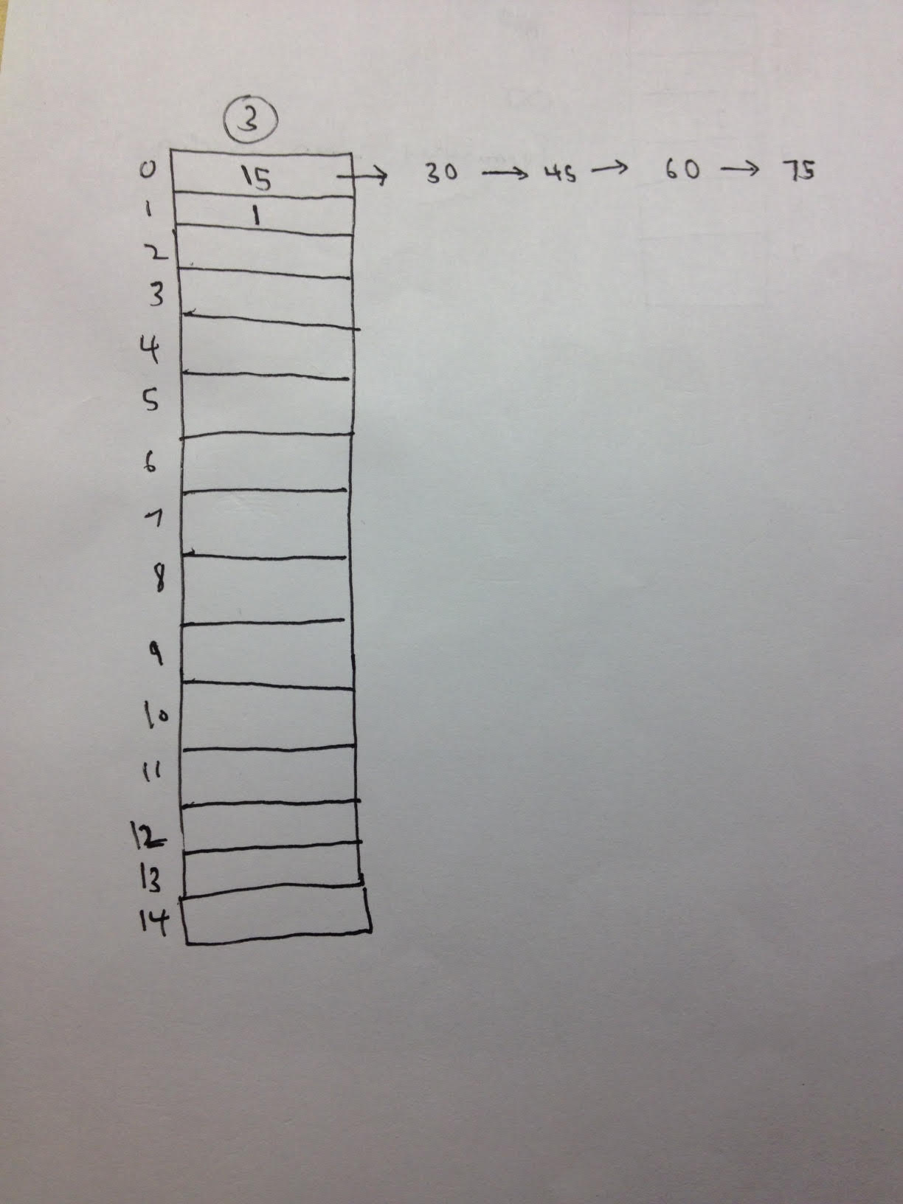Find 45 – 1 (array cell 3)
   4. Find 60 – 1 (array cell 4)
   5. Find 75 – 1 (array cell 5)
   6. Find 1 – 4 (3 attempts needed, array cell 6)
3. Separate Chaining; Array Size: 15
   1. Find 15 – 1 (array cell 0)
   2. Find 30 – 2 (array cell 0, link #2)
   3. Find 45 – 3 (array cell 0, link #3)
   4. Find 60 – 4 (array cell 0, link #4)
   5. Find 75 – 5 (array cell 0, link #5)
   6. Find 1 – 1 (array cell 1)

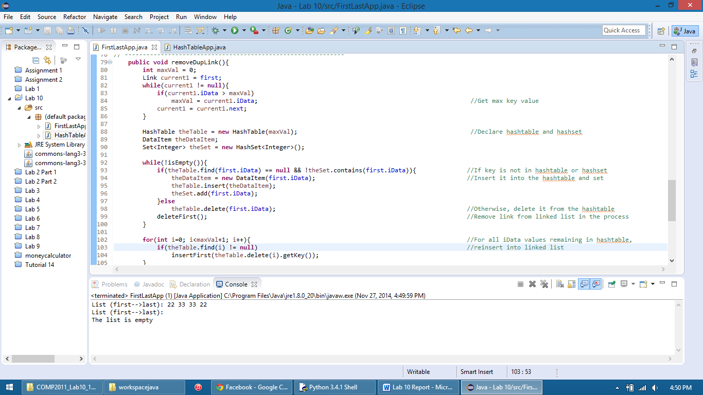Problem 3 Output: